GSM Adobe Commerce
B2B Orders Tracking Plan
Tracking and tagging plan for the Girl Scout Merchandise website on the Adobe Commerce platform. Based on the wireframes, designs, and block definitions from January 2026 in Phase 1 of the project.

Version: 2026-03-13

Page-Level Attributes

Adding Google Tag Manager (GTM)

Implementation Details

Dev / Staging
1. Paste this code as high in the <head> of the page as possible:
<!-- Google Tag Manager -->
<script>(function(w,d,s,l,i){w[l]=w[l]||[];w[l].push({'gtm.start':
new Date().getTime(),event:'gtm.js'});var f=d.getElementsByTagName(s)[0],
j=d.createElement(s),dl=l!='dataLayer'?'&l='+l:'';j.async=true;j.src=
'https://www.googletagmanager.com/gtm.js?id='+i+dl;f.parentNode.insertBefore(j,f);
})(window,document,'script','dataLayer','GTM-MSX7R7F4');</script>
<!-- End Google Tag Manager -->

2. Paste this code immediately after the opening <body> tag:
<!-- Google Tag Manager (noscript) -->
<noscript><iframe src="https://www.googletagmanager.com/ns.html?id=GTM-MSX7R7F4"
height="0" width="0" style="display:none;visibility:hidden"></iframe></noscript>
<!-- End Google Tag Manager (noscript) -->

Production
1. Paste this code as high in the <head> of the page as possible:

<!-- Google Tag Manager -->
<script>(function(w,d,s,l,i){w[l]=w[l]||[];w[l].push({'gtm.start':
new Date().getTime(),event:'gtm.js'});var f=d.getElementsByTagName(s)[0],
j=d.createElement(s),dl=l!='dataLayer'?'&l='+l:'';j.async=true;j.src=
'https://www.googletagmanager.com/gtm.js?id='+i+dl;f.parentNode.insertBefore(j,f);
})(window,document,'script','dataLayer','GTM-NXWW7L3J');</script>
<!-- End Google Tag Manager -->

2. Paste this code immediately after the opening <body> tag:
<!-- Google Tag Manager (noscript) -->
<noscript><iframe src="https://www.googletagmanager.com/ns.html?id=GTM-NXWW7L3J"
height="0" width="0" style="display:none;visibility:hidden"></iframe></noscript>
<!-- End Google Tag Manager (noscript) -->

DataLayer Push

Placement
This code must be placed above the GTM <script> tag in the <head> of the document.

Implementation Details
Object Path | Key | Data Type | Example | Notes
root | event | string | "page_init" | Bootstrap event. Fires once per page load.
environment | env | string | "production" | Controlled values: production, staging, qa, dev
environment | site | string | "gsusa_shop" | Stable site identifier. Low-cardinality.
environment | platform | string | "web" | Controlled values: web, mweb, ios_app, android_app
environment | version | string | "1.42.0" | Release/app version. Useful for debugging.
page | page_type | string | "orders" | Controlled taxonomy (homepage, plp, pdp, cart, checkout, confirmation, search, account, etc.).
page | page_name | string | "Wholesale – Order History" | Stable internal page label. Not display copy. naming convention pdp – {{ page title }}
page | path | string | "/" | Should use window.location.pathname.
page | referrer | string | "https://google.com" | Use document.referrer. May be empty.
page | previous_page_path | string | "/checkout/confirmation" | Internal previous path if available. Do not infer from referrer.
page | title | string | "Girl Scouts Shop" | Use document.title.
page | language | string | "en-US" | From <html lang> or browser.
user | login_state | string | "logged_in" | Controlled: logged_in, logged_out
user | user_id | string | "u_7f3a91c2" | Gigya ID. Not email-derived. Null if not logged in.
user | user_type | string | "returning_user" | Controlled: guest | new_user | returning_user | returned_customer – set to new new_user if account was created in the same day as session, returning_user if the user has no orders, returned_customer more than 1 order default to guess if non-known user
user | customer_type | string | "vendor" | Controlled: consumer, council administrator, vendor – be default set consumer, once the user identified based on login status or UX experience
user | audience_mode | string | "wholesale_parter” | Controlled: wholesale_partner | leaders | general. Set to leader if user toggles leader UX experience otherwise general
user | troop_id | string | “87” | Troop number of user.
user | council_id | string | “alaska…” | Council identifier.
user | em_sha256 | string | “lasidhgoaishdg” | User’s email, use SHA-256 encryption. Server-side only. Transmitted to ad platforms after Truyo consent granted.
user | ph_sha256 | string | “lasidhgoaishdg” | User’s phone, use SHA-256 encryption. Server-side only. Normalize: strip spaces/dashes/parens, include country code (+1).

Order History Page
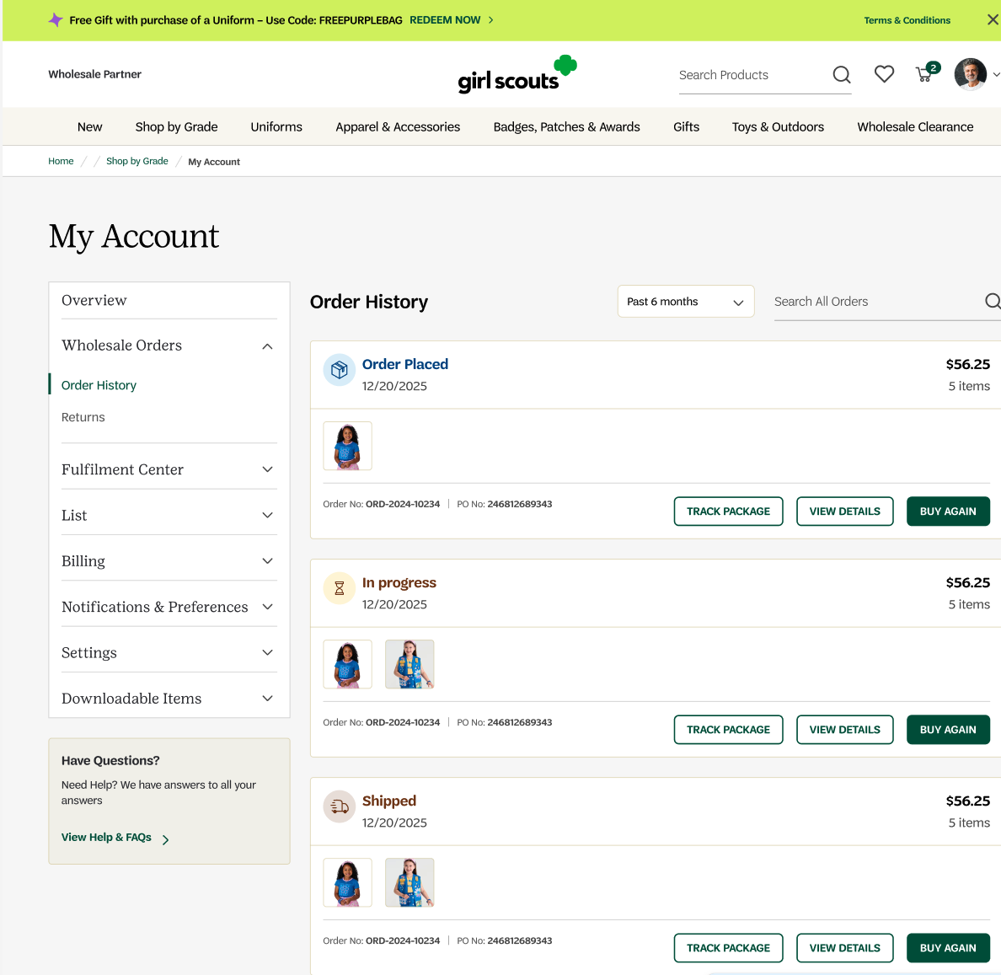

window.dataLayer.push({
event: "page_init",

environment: {
env: "production",
site: "gsusa_shop",
platform: "web",
version: "1.42.0"
},

page: {
page_type: "order_history",
page_name: "Wholesale Order History",
path: window.location.pathname,
referrer: document.referrer,
previous_page_path: '/checkout/confirmation'
title: document.title || null,
language: document.documentElement.lang || navigator.language || null
},

user: {
login_state: "logged_in",
user_id: "5648",
user_type: "return_users",
customer_type: "vendor",
audience_mode: "wholesale partner",
troop_id: null,
council_id: null,
em_sha256: null,
ph_sha256: null
}
});

Tracking button clicks

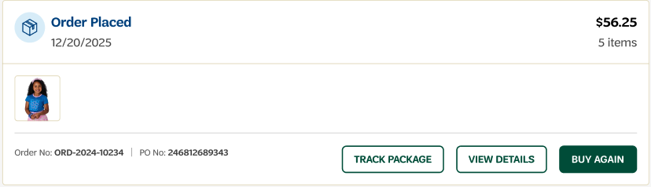

Track: TRACK PACKAGE button
Object Path | Key | Data Type | Example | Notes
root | event | string | "cta_track_package"
root | pst_transaction_id | string | "trn_3235" | Transaction id associated with transaction tied back to purchase payment.
root | order_id | string | "ord5168" | Order id associated with ordered, id shown to customer
root | po_number | string | "24246812689343" | Controlled values: web, mweb, ios_app, android_app
root | order_status | string | "order_processing" | Order status, example: order_placed, order_shipped, order_delievered, etc
root | carrier | string | "UPS" | Controlled taxonomy (homepage, plp, pdp, cart, checkout, confirmation, search, account, etc.).
root | tracking_number | string | "1Z999AA10123456784  " | Stable internal page label. Not display copy.
root | item_count | Int | 5

Business Questions:
- What items are users select?
- Where is my package right now?
- Has my order shipped?
- What is the expected delivery date?
- What is the internal order reference number?
- What purchase order number corresponds to this order?
- Can I match this order back to my internal procurement system?
- Does this order's PO number match what is in our AP system?
- Are there any discrepancies between PO-referenced spend and actual order totals?
- Are users reordering items
- Which orders are still open vs. fulfilled?

window.dataLayer.push({
event: "cta_track_package",

pst_transaction_id: "trn_235",
order_id: "ord_12351235",
po_number: "1234126",
order_status: "order_placed",
carrier: "UPS",
tracking_number: "1Z999AA10123456784",
item_count: 5
});

Track: VIEW DETAILS button
Object Path | Parameter | Type | Example | Rule
event | event | STRING | view_detail | Required. Must equal add_to_cart.
page | page_type | string | order_history | Required. Identifies page context where event fired.
page | page_name | string | Wholesale Order History | Friendly page name
root | pst_transaction_id | string | TXN-789456123 | Post-purchase spine. Sourced from payment/checkout system at time of purchase. Used as join key in BigQuery across all post-purchase events. Never equals order_id.
root | order_id | string | ORD-2024-10234 | Display-facing order identifier shown to customer in UI and emails. Sourced from OMS. Custom dimension — not a join key.
root | po_number | string | 246812689343 | Purchase order number. Custom dimension. Tappable in UI — copies to clipboard. Omit if not present on order.
root | order_status | string | order_placed | Snake_case. Must match backend enum exactly. Allowed values: order_placed | in_transit | delivered | cancelled
in_stock | in_stock | BOOLEAN | TRUE | Optional. Indicates product availability.
price | price | NUMBER | 52 | Optional page-level field. Final bundle price before tax and shipping.
original_price | original_price | NUMBER | 62 | Optional. Total catalog price before discount.
discount_amount | discount_amount | NUMBER | 10 | Optional. Calculated as original_price - price.
discount_flag | discount_flag | BOOLEAN | TRUE | Optional. Indicates whether discount applied.
ecommerce |  |  |  | Required. Full items from original order.
ecommerce | currency | string | "USD" | Required.
ecommerce { } | value | number | 29.00 | Required. Order value.
ecommerce { } | coupon | string | Welcome26 | Coupon used for discount
ecommerce { } | items | array | [{...}] | Required. Full items[] — same schema as add_to_cart.
ecommerce.items[] | index | integer | 0 | Product position of item
ecommerce.items[] | item_id | string | "SKU_10002" | Required. ID/Sku of the product
ecommerce.items[] | item_parent_sku | string | "SKU_10002" | Required. ID/Sku of the parent sku
ecommerce.items[] | line_group_id | string | "L001" | Required. shared ID code used to tie a primary product to all of its variations, modifications, and optional add-ons
ecommerce.items[] | item_type | string | "product" | Required. product | service_cost | customization.
ecommerce.items[] | item_name | string | "Official Adult Recycled Vest" | Required. Product Name
ecommerce.items[] | item_brand | string | "Girl Scouts" | Recommended. Product brand
ecommerce.items[] | item_category | string | "Apparel" | Recommended. Product category top level
ecommerce.items[] | item_category2 | string | null | Optional. Product category top level sub-level
ecommerce.items[] | item_category3 | string | null | Optional. Product category top level sub-level
ecommerce.items[] | item_category4 | string | null | Optional. Product category top level sub-level
ecommerce.items[] | item_category5 | string | null | Optional. Product category top level sub-level
ecommerce.items[] | list_type | string | recent_viewed | List type
ecommerce.items[] | list_id | string | plp_recent_viewed | Unique list name (category name)
ecommerce.items[] | list_name | string | "PLP - Recent Viewed" | Friendly name of list
ecommerce.items[] | item_variant | string | "Blue / M" | Optional. Variant from original order.
ecommerce.items[] | original_price | number | 54.00 | CONDITIONAL. Required when discounted.
ecommerce.items[] | discount_price | number | 44.00 | Optional. Discount price
ecommerce.items[] | price | number | 44.00 | Required. Price paid in original order.
ecommerce.items[] | wholesale_price | number | 44.00 | Optional. Wholesale price from original order.
ecommerce.items[] | retail_price | number | 54.00 | Optional. Retail price from original order.
ecommerce.items[] | discount | number | 10.00 | Optional.
ecommerce.items[] | coupon | string | null | Optional.
ecommerce.items[] | quantity | integer | 1 | Required.
ecommerce.items[] | service_type | string | null | CONDITIONAL when item_type = service_cost.
ecommerce.items[] | customization_type | string | null | CONDITIONAL when item_type = customization.

window.dataLayer = window.dataLayer || [];
window.dataLayer.push({

"event": "view_details",

"page": {
"page_type": "order_history",
"page_name": "Wholesale Order History",
},

"pst_transaction_id": "TXN-789456123",
"order_id": "ORD-2024-10234",
"po_number": "246812689343",
"order_status": "delivered",

"in_stock": true,
"price": 52,
"original_price": 62,
"discount_amount": 10,
"discount_flag": true,

"ecommerce": {

"currency": "USD",
"value": 52,
"coupon": "SPRING10",

"items": [
{
"index": "0",
"item_id": "SKU_10002",
"item_parent_sku": "SKU_10002",
"line_group_id": null,
"item_type": "product",
"item_name": "Official Adult Recycled Vest",
"item_brand": "Girl Scouts",
"item_category": "Apparel",
"item_category2": null,
"item_category3": null,
"item_category4": null,
"item_category5": null,
"list_type": "category",
"list_id": "daisy",
"list_name": "Daisy",
"item_variant": "Blue / M",
"original_price": 54.00,
"discount_price": 44.00,
"price": 44.00,
"wholesale_price": 44.00,
"retail_price": 54.00,
"discount": 10.00,
"coupon": null,
"quantity": 1,
"service_type": null,
"customization_type": null
}
// ... remaining order items follow same schema
]
};
</script>

Track: BUY AGAIN button
Object Path | Parameter | Type | Example | Rule
event | event | STRING | add_to_cart | Required. Must equal add_to_cart.
page | page_type | string | order_history | Required. Identifies page context where event fired.
page | page_name | string | Wholesale Order History | Friendly page name
root | pst_transaction_id | string | TXN-789456123 | Post-purchase spine. Sourced from payment/checkout system at time of purchase. Used as join key in BigQuery across all post-purchase events. Never equals order_id.
root | order_id | string | ORD-2024-10234 | Display-facing order identifier shown to customer in UI and emails. Sourced from OMS. Custom dimension — not a join key.
root | po_number | string | 246812689343 | Purchase order number. Custom dimension. Tappable in UI — copies to clipboard. Omit if not present on order.
root | order_status | string | order_placed | Snake_case. Must match backend enum exactly. Allowed values: order_placed | in_transit | delivered | cancelled
in_stock | in_stock | BOOLEAN | TRUE | Optional. Indicates product availability.
price | price | NUMBER | 52 | Optional page-level field. Final bundle price before tax and shipping.
original_price | original_price | NUMBER | 62 | Optional. Total catalog price before discount.
discount_amount | discount_amount | NUMBER | 10 | Optional. Calculated as original_price - price.
discount_flag | discount_flag | BOOLEAN | TRUE | Optional. Indicates whether discount applied.
ecommerce |  |  |  | Required. Full items from original order.
ecommerce | currency | string | "USD" | Required.
ecommerce { } | value | number | 29.00 | Required. Order value.
ecommerce { } | coupon | string | Welcome26 | Coupon used for discount
ecommerce { } | items | array | [{...}] | Required. Full items[] — same schema as add_to_cart.
ecommerce.items[] | index | integer | 0 | Product position of item
ecommerce.items[] | item_id | string | "SKU_10002" | Required. ID/Sku of the product
ecommerce.items[] | item_parent_sku | string | "SKU_10002" | Required. ID/Sku of the parent sku
ecommerce.items[] | line_group_id | string | "L001" | Required. shared ID code used to tie a primary product to all of its variations, modifications, and optional add-ons
ecommerce.items[] | item_type | string | "product" | Required. product | service_cost | customization.
ecommerce.items[] | item_name | string | "Official Adult Recycled Vest" | Required. Product Name
ecommerce.items[] | item_brand | string | "Girl Scouts" | Recommended. Product brand
ecommerce.items[] | item_category | string | "Apparel" | Recommended. Product category top level
ecommerce.items[] | item_category2 | string | null | Optional. Product category top level sub-level
ecommerce.items[] | item_category3 | string | null | Optional. Product category top level sub-level
ecommerce.items[] | item_category4 | string | null | Optional. Product category top level sub-level
ecommerce.items[] | item_category5 | string | null | Optional. Product category top level sub-level
ecommerce.items[] | list_type | string | recent_viewed | List type
ecommerce.items[] | list_id | string | plp_recent_viewed | Unique list name (category name)
ecommerce.items[] | list_name | string | "PLP - Recent Viewed" | Friendly name of list
ecommerce.items[] | item_variant | string | "Blue / M" | Optional. Variant from original order.
ecommerce.items[] | original_price | number | 54.00 | CONDITIONAL. Required when discounted.
ecommerce.items[] | discount_price | number | 44.00 | Optional. Discount price
ecommerce.items[] | price | number | 44.00 | Required. Price paid in original order.
ecommerce.items[] | wholesale_price | number | 44.00 | Optional. Wholesale price from original order.
ecommerce.items[] | retail_price | number | 54.00 | Optional. Retail price from original order.
ecommerce.items[] | discount | number | 10.00 | Optional.
ecommerce.items[] | coupon | string | null | Optional.
ecommerce.items[] | quantity | integer | 1 | Required.
ecommerce.items[] | service_type | string | null | CONDITIONAL when item_type = service_cost.
ecommerce.items[] | customization_type | string | null | CONDITIONAL when item_type = customization.

window.dataLayer = window.dataLayer || [];
window.dataLayer.push({

"event": "add_to_cart",
"page": {
"page_type": "order_history",
"page_name": "Wholesale Order History",
},

"pst_transaction_id": "TXN-789456123",
"order_id": "ORD-2024-10234",
"po_number": "246812689343",
"order_status": "order_placed",

"in_stock": true,
"price": 52,
"original_price": 62,
"discount_amount": 10,
"discount_flag": true,

"ecommerce": {

"currency": "USD",
"value": 52,
"coupon": "SPRING10",

"items": [
{
"index": "0",
"item_id": "SKU_10002",
"item_parent_sku": "SKU_10002",
"line_group_id": null,
"item_type": "product",
"item_name": "Official Adult Recycled Vest",
"item_brand": "Girl Scouts",
"item_category": "Apparel",
"item_category2": null,
"item_category3": null,
"item_category4": null,
"item_category5": null,
"list_type": "category",
"list_id": "daisy",
"list_name": "Daisy",
"item_variant": "Blue / M",
"original_price": 54.00,
"discount_price": 44.00,
"price": 44.00,
"wholesale_price": 44.00,
"retail_price": 54.00,
"discount": 10.00,
"coupon": null,
"quantity": 1,
"service_type": null,
"customization_type": null
}
// ... remaining order items follow same schema
]
};
});

Track: Exchange Button
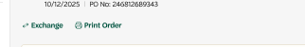
window.dataLayer = window.dataLayer || [];
window.dataLayer.push({

"event": "view_exchange_modal",

"page": {
"page_type": "order_history",
"page_name": "Wholesale Order History",
},

"pst_transaction_id": "TXN-789456123",
"order_id": "SO18888888",
"order_placed_date": "2026-01-24",
"po_number": "246812689343",
"order_status": "delivered",
"exchange_order_id": "987654123432",

"in_stock": true,
"price": 3,
"original_price": 3,
"discount_amount": null,
"discount_flag": false,

"exchange_quantity": 1,
"remaining_quantity": 1,
"product_condition": "good",
"exchange_reason": "fitting_issues", // dropdown — enumerated
"ecommerce": {

"currency": "USD",
"value": 52,
"coupon": "SPRING10",

"items": [
{
"index": "0",
"item_id": "SKU_10002",
"item_parent_sku": "SKU_10002",
"line_group_id": null,
"item_type": "product",
"item_name": "Official Adult Recycled Vest",
"item_brand": "Girl Scouts",
"item_category": "Apparel",
"item_category2": null,
"item_category3": null,
"item_category4": null,
"item_category5": null,
"list_type": "category",
"list_id": "daisy",
"list_name": "Daisy",
"item_variant": "Blue / M",
"original_price": 54.00,
"discount_price": 44.00,
"price": 44.00,
"wholesale_price": 44.00,
"retail_price": 54.00,
"discount": 10.00,
"coupon": null,
"quantity": 1,
"service_type": null,
"customization_type": null
}
// ... remaining order items follow same schema
]
}
};

Track: When the model opens

window.dataLayer = window.dataLayer || [];
window.dataLayer.push({

"event": "view_exchange_form",

"page": {
"page_type": "order_history",
"page_name": "Wholesale Order History",
},

"pst_transaction_id": "TXN-789456123",
"order_id": "SO18888888",
"order_placed_date": "2026-01-24",
"po_number": "246812689343",
"order_status": "delivered",
"exchange_order_id": "987654123432",

"in_stock": true,
"price": 3,
"original_price": 3,
"discount_amount": null,
"discount_flag": false,

"exchange_quantity": 1,
"remaining_quantity": 1,
"product_condition": "good",
"exchange_reason": "fitting_issues",

"ecommerce": {

"currency": "USD",
"value": 52,
"coupon": "SPRING10",

"items": [
{
"index": "0",
"item_id": "SKU_10002",
"item_parent_sku": "SKU_10002",
"line_group_id": null,
"item_type": "product",
"item_name": "Official Adult Recycled Vest",
"item_brand": "Girl Scouts",
"item_category": "Apparel",
"item_category2": null,
"item_category3": null,
"item_category4": null,
"item_category5": null,
"list_type": "category",
"list_id": "daisy",
"list_name": "Daisy",
"item_variant": "Blue / M",
"original_price": 54.00,
"discount_price": 44.00,
"price": 44.00,
"wholesale_price": 44.00,
"retail_price": 54.00,
"discount": 10.00,
"coupon": null,
"quantity": 1,
"service_type": null,
"customization_type": null
}
// ... remaining order items follow same schema
]
}
});

Track: When the user submits an exchange

window.dataLayer = window.dataLayer || [];
window.dataLayer.push({

"event": "submit_exchange",

"page": {
"page_type": "order_history",
"page_name": "Wholesale Order History",
},

"pst_transaction_id": "TXN-789456123",
"order_id": "SO18888888",
"order_placed_date": "2026-01-24",
"po_number": "246812689343",
"order_status": "delivered",
"exchange_order_id": "987654123432",

"in_stock": true,
"price": 3,
"original_price": 3,
"discount_amount": null,
"discount_flag": false,

"exchange_quantity": 1,
"remaining_quantity": 1,
"product_condition": "good",
"exchange_reason": "fitting_issues",

"ecommerce": {

"currency": "USD",
"value": 52,
"coupon": "SPRING10",

"items": [
{
"index": "0",
"item_id": "SKU_10002",
"item_parent_sku": "SKU_10002",
"line_group_id": null,
"item_type": "product",
"item_name": "Official Adult Recycled Vest",
"item_brand": "Girl Scouts",
"item_category": "Apparel",
"item_category2": null,
"item_category3": null,
"item_category4": null,
"item_category5": null,
"list_type": "category",
"list_id": "daisy",
"list_name": "Daisy",
"item_variant": "Blue / M",
"original_price": 54.00,
"discount_price": 44.00,
"price": 44.00,
"wholesale_price": 44.00,
"retail_price": 54.00,
"discount": 10.00,
"coupon": null,
"quantity": 1,
"service_type": null,
"customization_type": null
}
// ... remaining order items follow same schema
]
}
});

